Project 2: 1-D Multigroup FDM P3 and B1 Codes

2015-22938 김동훈
Part B. B1 Leakage Correction
1. Derive B1 Equation
Spatial, Energy, Angle dependent 1-D Slab geometry, Homogeneous media
Transport Eq.
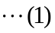
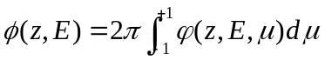 : 0-th moment
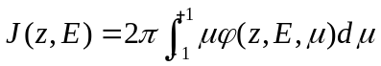 : 1-th moment
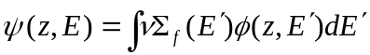
공간과 에너지에 대해 변수 분리를 한다.
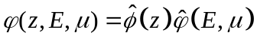
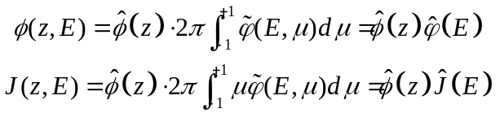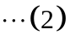
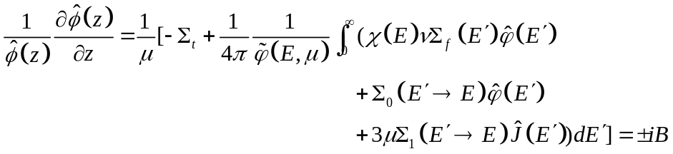
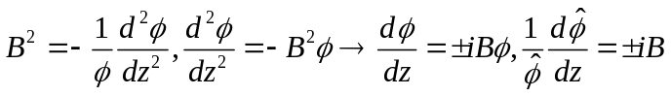
이 해는 다음과 같다.
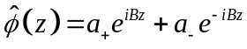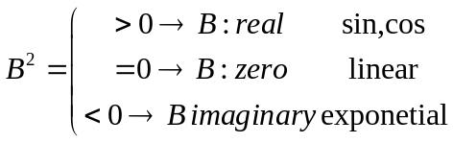
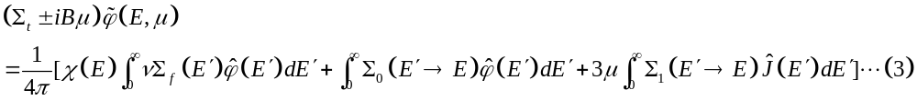(3)을 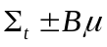로 나누고 르장드르 다항식으로 angular Flux를 전개하면
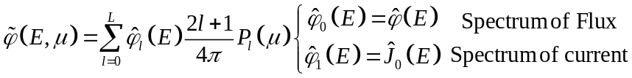
L에 1을 대입한다.
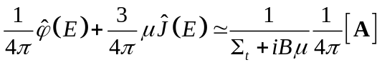
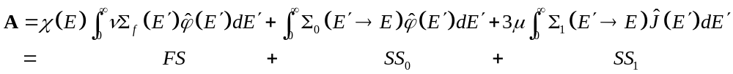

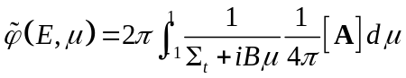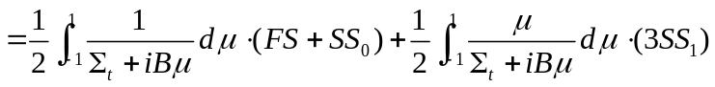
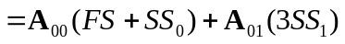
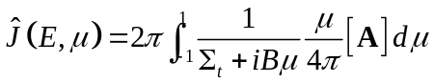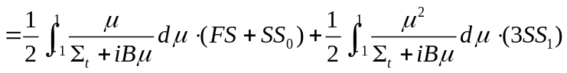
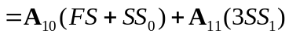
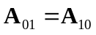

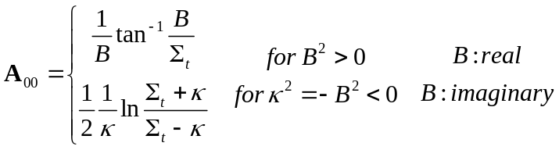
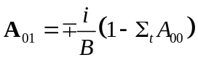
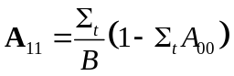
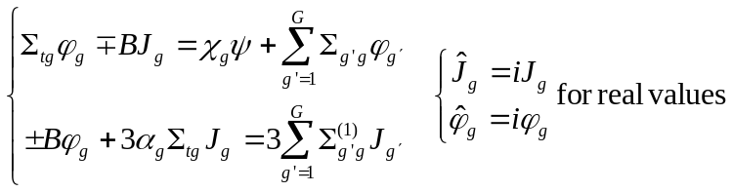
행렬형태로 정리한다.
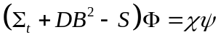
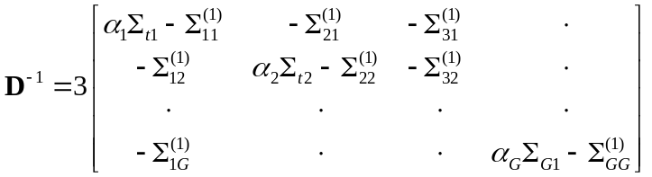
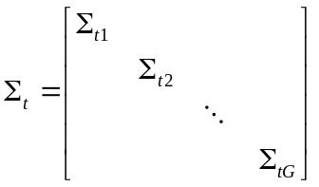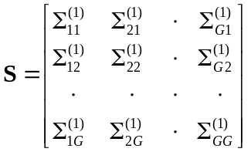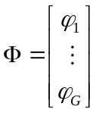
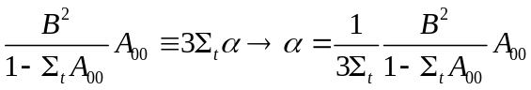

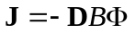
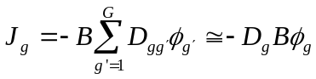
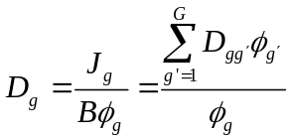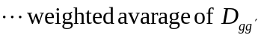
위의 유도를 통해서 얻은 행렬식을 코드에 적용하면 된다.

1.2 Buckling Search Algorithm
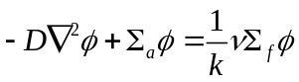
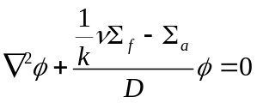
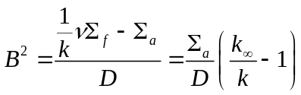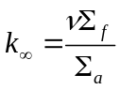
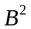 를 1/k의 함수로 보고 선형 근사를 한다.

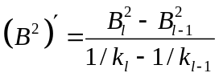
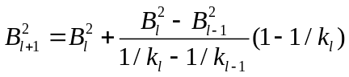
버클링은 위의 식을 통해 찾을 수 있다.

2. Prepare an input processing routine that reads in the multigroup cross section data which are given in the following format.
int B1LeakageCorrection::readInput(string inName)
{
ifstream fin(inName);
string str, str1;
int i, j, k;
do {
fin >> str;
} while (str != "Scattering_TrC");
fin >> str;
do {
str1 = str;
for (i = 0; i < 11; i++) fin >> str;
} while (str != "from");
nGrp = atof(str1.c_str());
fin.close();
fin.open(inName);
do {
fin >> str;
} while (str != "Scattering_TrC");
allocateVariable();
for (i = 0; i < nGrp; i++) {
fin >> str;
fin >> str; upperEB(i) = atof((str.c_str()));
fin >> str; xs_abs(i) = atof(str.c_str());
fin >> str; xs_scat(i) = atof(str.c_str());
fin >> str; nu_fis(i) = atof(str.c_str());
fin >> str; chi(i) = atof(str.c_str());
fin >> str; inf_spec(i) = atof(str.c_str());
fin >> str; xs_total(i) = atof(str.c_str());
fin >> str; xs_trans(i) = atof(str.c_str());
fin >> str; smgg_TrC(i) = atof(str.c_str());
fin >> str; xs_scat_TrC(i) = atof(str.c_str());
}
fin >> str >> str >> str >> str; fin >> str;
while (!fin.eof()) {
i = atoi(str.c_str());
fin >> str;
j = atoi(str.c_str());
fin >> str; sm_p0(j - 1, i - 1) = atof(str.c_str());
fin >> str; sm_p1(j - 1, i - 1) = atof(str.c_str());
fin >> str;
}
return 0;
}
Group 수를 먼저 읽은 allocateVariable()함수에서 변수를 정의 하고 변수의 적절한 위치에 주어진 값을 넣었다.

3. Write a routine that constructs the modified P1 scattering matrix (D⁻¹) as a function of Buckling and total cross section. Refer to the MATLAB function attached at the end to determine the alpha values. Then write a routine that finds the inverse of D⁻¹ by repeated solutions of the linear system involving D⁻¹ with the RHS replaced with elementary vectors.

calAlpha();
setMatrixD();
int B1LeakageCorrection::calAlpha()
{
int i;
double A00;
absB = sqrt(abs(Bsq));
if (Bsq > 0) {
for (i = 0; i < nGrp; i++) {
A00 = atan(absB / xs_total(i)) / absB;
alpha(i) = Bsq*A00 / 3 / xs_total(i) / (1 - xs_total(i) * A00);
}
}
else if (Bsq < 0) {
for (i = 0; i < nGrp; i++) {
A00 = atan(absB / xs_total(i)) / absB;
alpha(i) = (log((xs_total(i) + absB) / (xs_total(i) - absB))) / (2 * absB);
}
}
else for (i = 0; i < nGrp; i++) alpha(i) = 0.;
return 0;
}
int B1LeakageCorrection::setMatrixD()
{
int i, j;
invDMat = -sm_p1;
for (i = 0; i < nGrp; i++) {
invDMat(i, i) += alpha(i)*xs_total(i);
}
invDMat = 3 * invDMat;
DMat = invDMat.inverse();
return 0;
}

4. Write a routine that solves the eigenvalue problem (7). Note that you don’t need to actually construct fission matrix because you only need the fission spectrum and the normalized fission source. The spectrum obtained with zero leakage should be close to the groupwise fluxes given in the input file once they are normalized. The multiplication factor for this case is 1.37627.

double B1LeakageCorrection::maxeig()
{
int i = 0;
VectorXd xd;
for (i = 0; i < nGrp; i++) phi(i) = 1.;
double lam = 1, lamd, sigma;
for (i = 0; i<1000; i++)
{
xd = phi;
phi = AMat*xd / lam;
// x=A*x/lam;
lamd = lam;
lam = lamd*sqrt((phi.dot(phi) / (phi.dot(xd))));
if (abs(lam - lamd)<1e-7)
break;
}
sigma = 1 - lamd / lam;
lam = lam / (1 - sigma);
if (i == 1000)
std::cout << " eigenvalue not converged within 1000 iterations" << std::endl;
return lam;
}

5. Implement a search algorithm that changes the buckling value to find the unity eigenvalue. Use this algorithm to find the critical buckling. Then determine the current spectrum and consequently the diffusion coefficient for each group.
5.1 K-inf and Critical Buckling
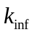 =1.37637
=0.0065012
문제에서 주어진 와 같은 값을 얻었고, Critical Buckling의 값은 위와 같다.

5.2 Buckling Search
1.2의 알고리즘을 통해서 k=1 이 되는 버클링을 찾았다.
그 결과를 그린 그래프는 아래와 같다.
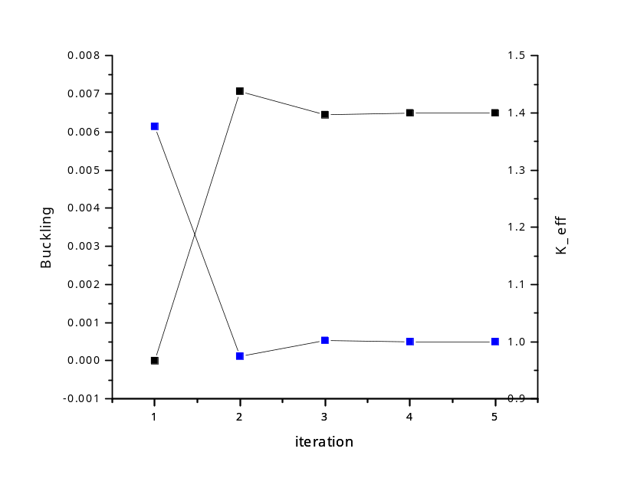

int B1LeakageCorrection::b1man(string inName)
{
int i, j;
ofstream fout1("output.txt");
readInput(inName);
for (i = 0; i < nGrp; i++) {
MMat(i, i) = xs_total(i);
}
for (i = 0; i < nGrp; i++) {
for (j = 0; j < nGrp; j++) {
MMat(i,j) = MMat(i, j)-1.0*sm_p0(i,j);
}
}
FMat = chi*nu_fis.transpose();
AMat = MMat.inverse()*FMat;
double keff0=maxeig();
double kinf=keff0;
Bsq = 0;
for (i = 0; i < nGrp; i++) phi(i) = 1.;
double Bsqd = 0;
double keffd, keff = keff0;
Bsq = 0.00000000001;
double Bsqn;
int itr = 0;
keffd = keff0;
do {
itr = itr + 1;
calAlpha();
setMatrixD();
MMat = -sm_p0 + Bsq*DMat;
for (i = 0; i < nGrp; i++) {
MMat(i, i) += xs_total(i);
}
AMat = MMat.inverse()*FMat;
keff=maxeig();
cout << itr << '\t' << Bsq << '\t' << keff << endl;
fout1 << itr << '\t'<<Bsq << '\t' << keff << endl;
Bsqn = (1 - 1 / keff) / (1 / keff - 1 / keffd)*(Bsq - Bsqd) + Bsq;
Bsqd = Bsq; Bsq = Bsqn;
keffd = keff;
bConverge = (abs(keff - 1.)) > 1e-7;
} while (bConverge);
VectorXd Current;
Current = VectorXd::Zero(nGrp);
absB = sqrt(abs(Bsq));
Current = DMat*absB*phi;
DifCoeffi = (DMat*phi);
for (i = 0; i < nGrp; i++) {
DifCoeffi(i) /= phi(i);
}
fout1 << endl;
fout1.setf(ios::scientific);
fout1 << setprecision(5);
int width=12;
fout1 << "Grp"<< setw(width) << "upperEB" << setw(width) << "inf_spec " << setw(width+10) << "normalizedFlux/delu" << setw(width+10)<<"normalizedJ/delu"<<endl;
width = 15;
for (i = 0; i < nGrp-1; i++) {
fout1 << setw(2) << i << setw(width) << upperEB(i) << setw(width) << inf_spec(i)/inf_spec.sum() / log(upperEB(i) / upperEB(i + 1)) << setw(width) << phi(i) / (phi.sum()) / log(upperEB(i) / upperEB(i + 1)) << setw(width) << Current(i) / (Current.sum()) / log(upperEB(i) / upperEB(i + 1)) <<endl;
}
i = nGrp - 1;
fout1 << setw(2) <<i<< setw(width) << upperEB(i) << setw(width) << inf_spec(i) / inf_spec.sum() / log(10) << setw(width) << phi(i) / (phi.sum()) /log(10)<< setw(width) << Current(i) / (Current.sum()) / log(10) << endl;
fout1 << endl;
fout1 << "DifCoeff" << endl;
for (i = 0; i < nGrp ; i++) {
fout1 << setw(width) <<DifCoeffi(i)<<setw(width)<<1./xs_trans(i)/3<< endl;
}
return 0;
}

6. Compare the critical spectrum with the zero-leakage spectrum and discuss the difference in the spectra. Compare the flux and current spectra at the critical condition. Compare the diffusion coefficients obtained with the transport cross section based values and discuss the importance of the leakage correction.
아래의 그래프를 보면 Leakage Correction을 한 경우에 Thermal spectrum이 상대적으로 더 작은 것을 알 수 있다. 실제의 경우 핵분열을 통해 나온 속중성자가 Thermal 영역으로 가는 동안에 leakage를 통해 빠져나갈 수 있고 그 영향을 고려한 것이 Leakage Correction이므로 B1 Leakage Correction을 한 것이 더 실제에 가까울 것이다. 따라서 Leakage Correction은 필요하다.
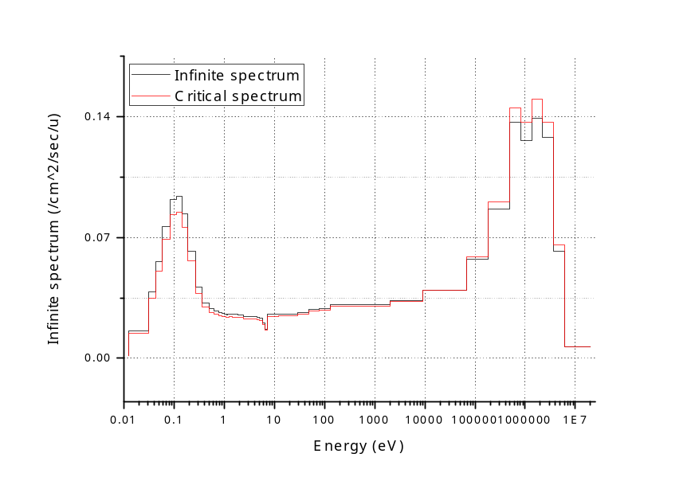
아래의 그래프는 Critical condition에서의 flux와 current의 spectrum이다.
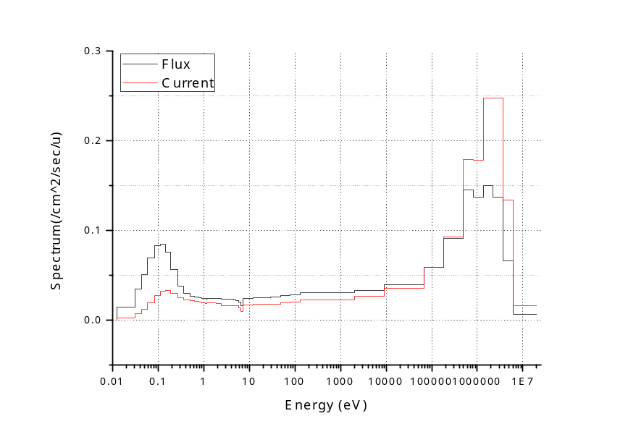
아래의 그래프는 B1 Leakage Correction과 transport correction을 통한 Diffusion Coefficient이다. 두 Diffusion coefficient의 차이가 큰 영역이 두 부분 나타나는데 그 영역에서 Flux와 current의 상대적인 값이 큰 편이고 따라서 leakage correction이 중요하다.
